hi

Mid-Term Examination (Fall, 2000-2001)
(SOLUTION)
ENGG 201 - Behaviour of Liquids, Gases and Solids

October 25, 2000 Time Allowed: 90 minutes

PROBLEM I (20 points)
The equation for incompressible laminar flow over a flat plate with zero pressure drop is given by:
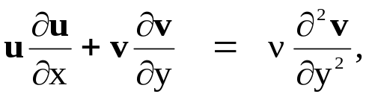
where u and v are velocities, and x and y are lengths.
1. Use the fact that the above equation is dimensionally homogeneous to determine the dimension of the parameter ν.
The equation is dimensionally homogeneous: [LHS]=[RHS]
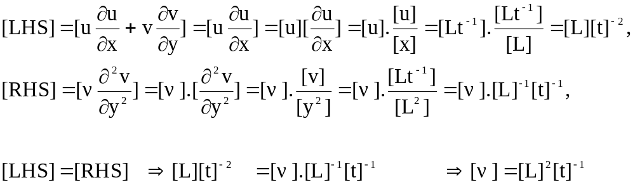

2. The parameter ν is called the kinematic viscosity, and is related to the dynamic viscosity (or simply viscosity) μ and the density ρ. Use dimensions to determine the expression of ν in terms of μ and ρ.
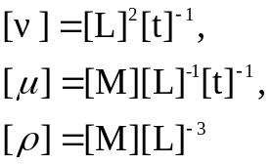
We see that the dimension of mass [M] appears in the dimension of both ρ and μ, but not in that of ν. Therefore it should be eliminated by taking a ratio of μ and ρ. The appropriate ratio is ν=μ/ρ

3. Determine the S.I. units of the kinematic viscosity ν.

PROBLEM II (20 points)
The following vapor-liquid equilibrium data for ethylene are given.
Temperature (ºC) | Absolute Pressure (kPa) | Specific Volume (m³/kg)
Temperature (ºC) | Absolute Pressure (kPa) | Liquid | Vapor
-17.8 | 267 | 0.00244 | 0.01880
-6.7 | 350 | 0.00268 | 0.01323
4.4 | 451 | 0.00314 | 0.00868
9.9 | 512 | 0.00437 | 0.00437
Using these data and your knowledge of the pressure-volume diagrams for pure components, answer the following questions:

1. What are the critical temperature, critical pressure and critical volume of ethylene?

Critical temperature (ºC) | 9.9
Critical pressure (kPa) | 512
Critical specific volume (m³/kg) | 0.00437

2. What is the vapor pressure of ethylene at 0.0 ºF?
0.0 ºF = -17.8 ºC
Vapour Pressure = 267 kPa

3. 100 kg of ethylene is contained in a rigid vessel of 0.45 m³ volume and kept at a temperature of –6.7 ºC. What is the mass and volume of ethylene vapor in the tank.

Specific volume of the vapor-liquid mixture = 0.45/100 = 0.0045 m³ /kg

Using the lever rule, the mass of vapour = 100 kg * (0.0045-0.00268)/(0.01323 – 0.00268)
= 17.25 kg.

Volume of the vapour = mass of the vapour*specific volume of the vapour
=17.25 kg * 0.01323 m³/kg = 0.228 m³

mass of vapour: 17.25kg
volume of vapour: 0.228 m³

4. If the temperature of the vessel is increased to 20 ºC, what phases will be present in the tank?

The temperature is higher than the critical temperature, hence only gas can be present.

Gas

PROBLEM III (30 points)

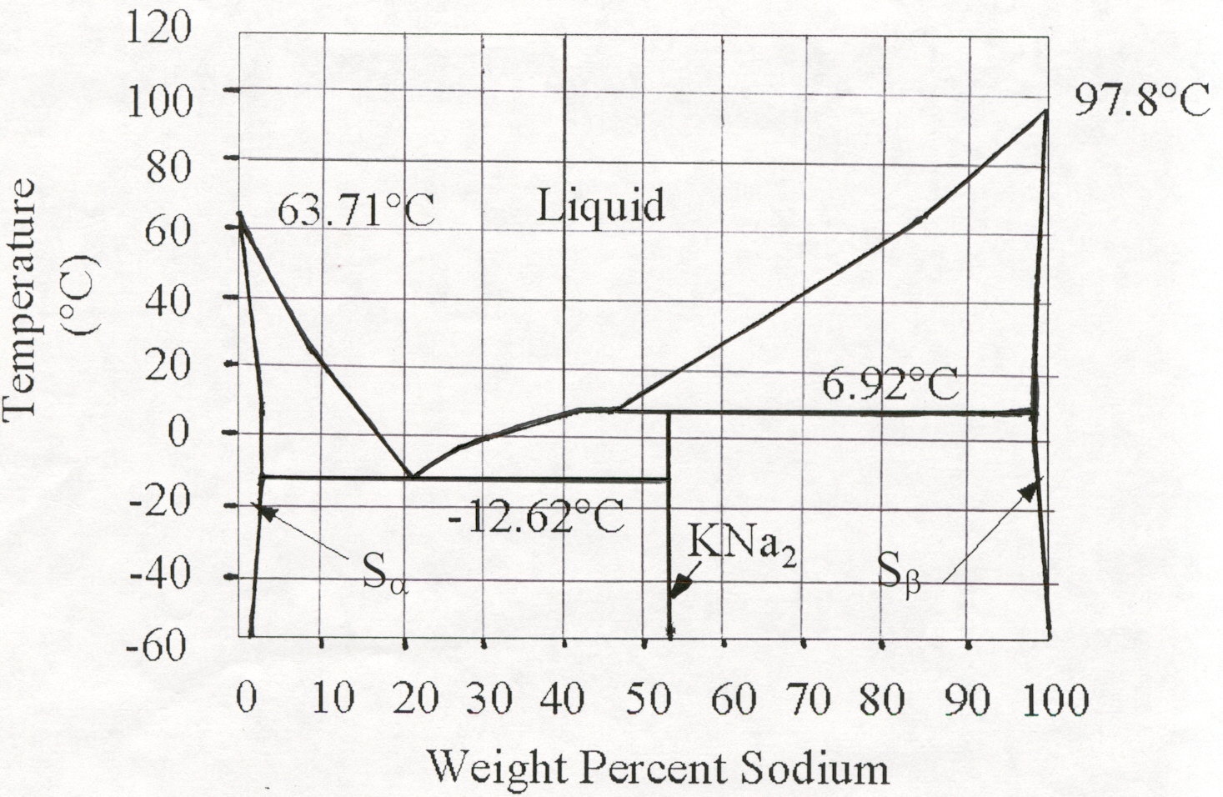

Figure 1
Figure1 shows a solid-liquid phase diagram for a Sodium-Potassium system at fixed pressure.
N.B. Molar mass of Sodium (Na): M_{Na} =23kg/kmol
Molar mass of Potassium (K): M_{K} =39kg/kmol
T_{Na}=97.8ºC
1. What are the melting temperatures of pure Sodium (Na) and Potassium (K)?

T_{K}=63.71ºC

2. What is the maximum solubility of Potassium in Sodium, and at what temperature is this maximum solubility reached?
Maximum solubility ~2wt%

Temperature=6.92ºC

3. A mixture consisting of 0.4kg of Sodium and 0.6kg of Potassium is initially held at a temperature of 80 ºC. The mixture is cooled down.
To~ 5.5 ºC
- At what temperature does a second phase start to form?

- Give the exact composition of the phases present at that temperature (in wt% of Na).
(N.B. You do not need to read the diagram to answer this question)
Liquid: 40 wt%
KNa₂ : 2*M_{Na} /(2* M_{Na} +M_{K})=46/85=0.541 or 54.1 wt%

- The above mixture is cooled down to a temperature T=0ºC. The temperature is then held fixed, and Potassium is added till the mass concentration of Sodium in the final mixture becomes equal to 10 wt%. Answer the following questions:
  - What is the amount of Potassium that has been added?
Let x be the amount of Potassium added:
w_{Na}=0.1 = 0.4/(0.4+0.6+x) ➔ x=3kg
Amount of Potassium added: 3.0kg

  - What is the total mass of the mixture, m_{t}?
m_{t} = 1kg +3kg =4kg.
m_{t}=4.0kg

- The mixture from question (c) is cooled down to a temperature T=-12.62ºC. Determine the number of phases present and their composition expressed in wt% of Na.

Three phases: Liquid, solid Sα and solid KNa₂
Liquid ~ 22 wt% Na
Sα ~ 3 wt% Na
KNa₂ : 54.1 wt% Na

- The above mixture is now brought to a temperature T=-40ºC. Determine:
  - The number of phases present.
Two phases

  - The composition of all phases expressed in wt% of Na.
Sα ~ 2 wt% Na
KNa₂ : 54.1 wt% Na

  - The mass of each phase present in the system.

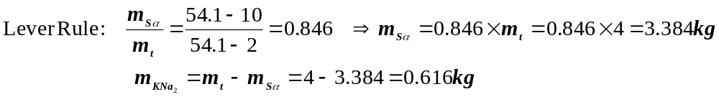

PROBLEM IV (30 points)
A rigid tank of one m³ internal volume is filled with 75 moles of pure argon (molar mass = 39.948kg/kmol). The tank is maintained at a constant temperature of 25 ºC.
1. Assuming ideal gas behaviour, calculate the following:
- Pressure in the tank.
P = (nRT)/V = (75 * 8.314 * 298.15)/1 = 185,911 Pa = 185.911 kPa
P= 185.911 kPa

- Mean free path of the gas molecules.
From Table 3-6, b_{o} = 0.054
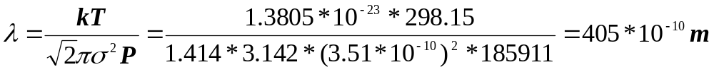
λ = 405*10⁻¹⁰ m

- Constant-volume molar heat capacity of the gas.
C_{v} = 3R/2 = 3*8.314/2 = 12.471J/(mol K)
C_{v} = 12.471J/(mol.K)

- Amount of heat energy needed to increase the temperature of the gas to 75 ºC.
Q = nC_{v} ΔT = 75*12.471*(75-25) = 46766 J
Q= 46766 J

2. One kg of pure oxygen (O₂, molar mass = 31.999 kg/kmol) is then added to the tank keeping the temperature constant at 25 ºC. For this mixture of argon and oxygen, calculate the following:
- Gas composition expressed in mass fractions.
Mass of argon = 75 mol * 0.039948 kg/mol = 2.9961 kg
Mass of oxygen = 1.0 kg
Total mass = 3.9961 kg
Mass fraction of argon = 2.9961/3.9961 = 0.750
Mass fraction of oxygen = 1/3.9961 = 0.250
Ar = 0.750 wt% ; O₂ = 0.250wt%

- Gas composition expressed in mole fractions.
Moles of O₂ = 1/31.999 = 0.03125 kmol = 31.25 mol
Moles of Ar = 75 mol
Total moles = 75 + 31.25 = 106.25 mol
Mole fraction of Ar = 75/106.25 = 0.706
Mole fraction of O₂ = 1 – 0.706 = 0.294

Ar = 0.706 mol% ; O₂ = 0.294 mol%

- Partial pressure of oxygen in the tank.

P₂ =P*y₂= (n₂ RT)/V = (31.25 * 8.314 * 298.15)/1 = 77,463 Pa

77.463 kPa

